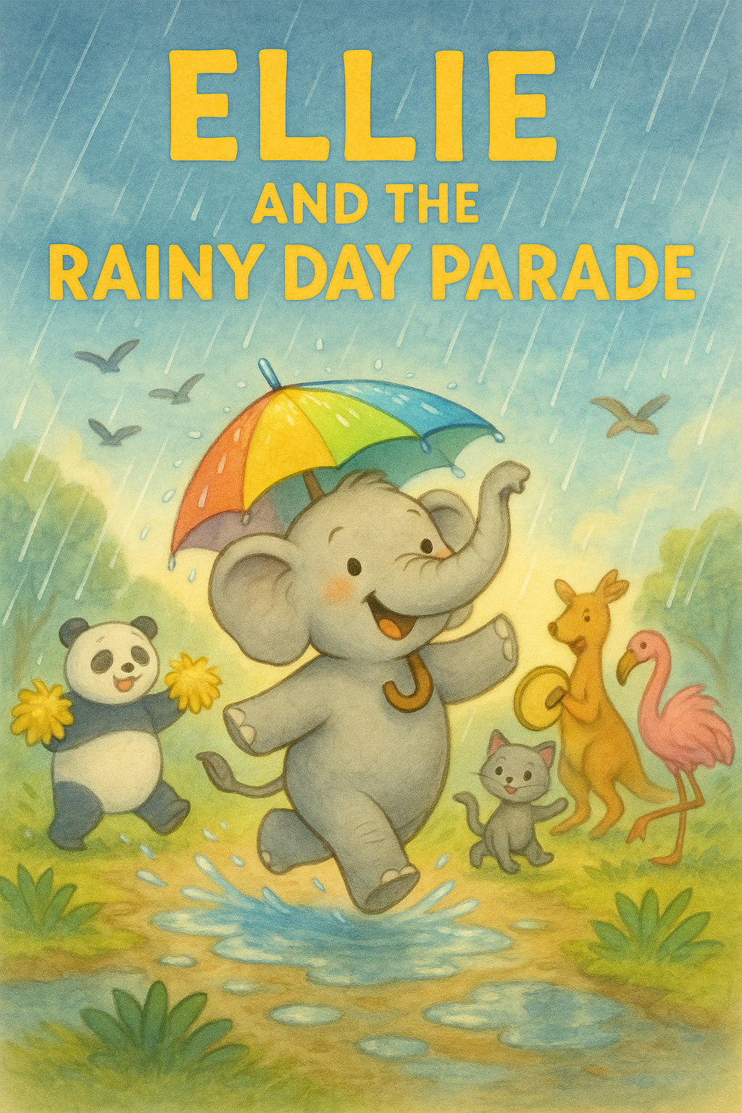

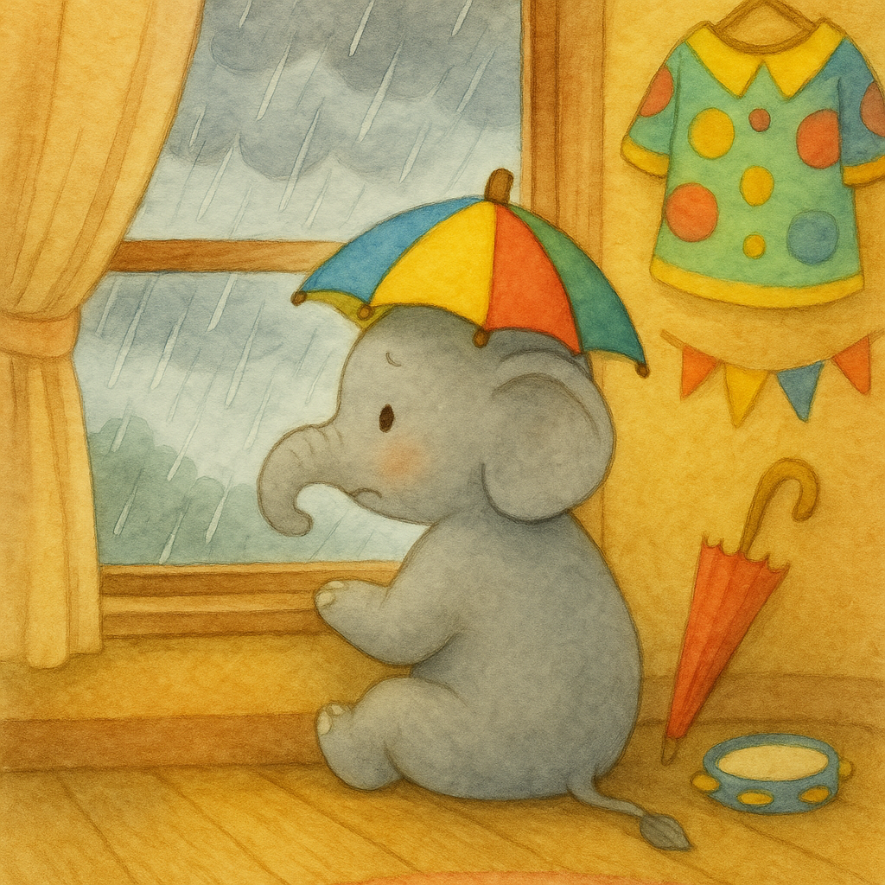

She practiced walking  
 in straight lines, spinning with her  
 umbrella, and smiling at the crowd.

But on the morning of the parade, Ellie woke up to dark clouds and a steady, heavy rain. Drops splattered on the window like little taps saying, “Not today.”   
Ellie frowned. “What if the parade is canceled?”

Ellie was a small elephant who loved parades more than anything. She loved the drums, the music, the waving flags, and especially   
the sparkly costumes. Every spring,   
her town held the Sunny Parade,   
and Ellie had been   
waiting all year to march   
in it with her colorful   
umbrella hat.

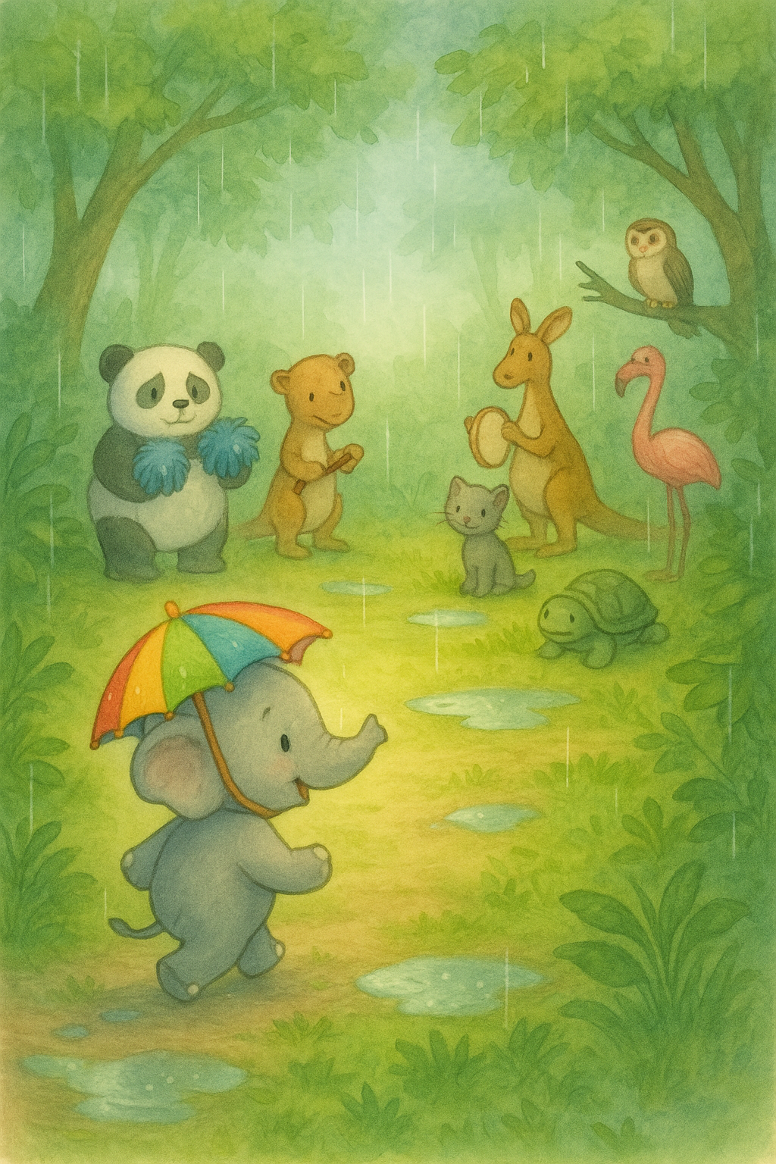

She put on her umbrella hat anyway and walked to the square. One by one, the other animals came too: pandas with pom-poms, kangaroos with tambourines, flamingos in feathers. They all looked disappointed.

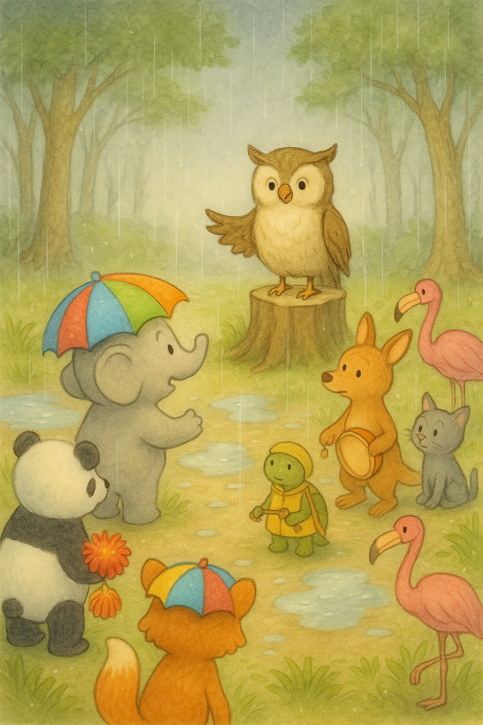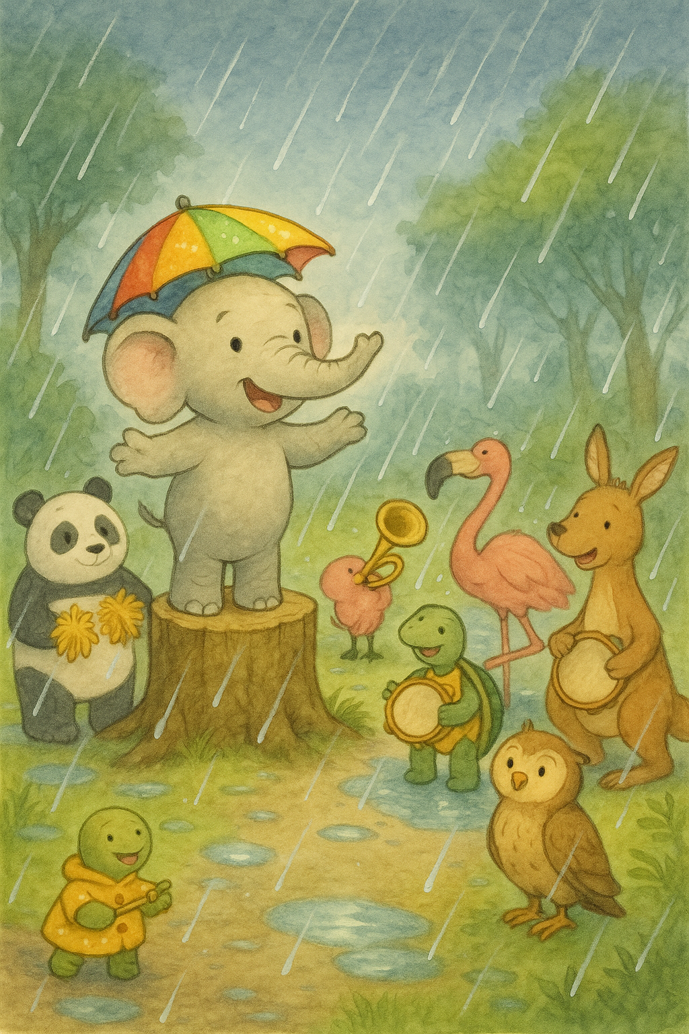

“But I practiced so much,” whispered a young turtle with tap shoes. “Me too,” said Ellie quietly.   
Then Ellie had an idea.

The mayor, a wise old owl, fluttered to the top of a bench and said, “Friends, the rain is too heavy. We must cancel the Sunny Parade.”   
A loud sigh floated through the crowd.

Then the panda did a pom-pom shake. The kangaroo tapped a beat on her tambourine.   
So the parade   
began, right in the   
middle of the rain!

She climbed onto a tree stump and called out, “What if we have a Rainy Day Parade instead? We can splash in puddles, twirl in the rain, and play soggy music!” Everyone paused.

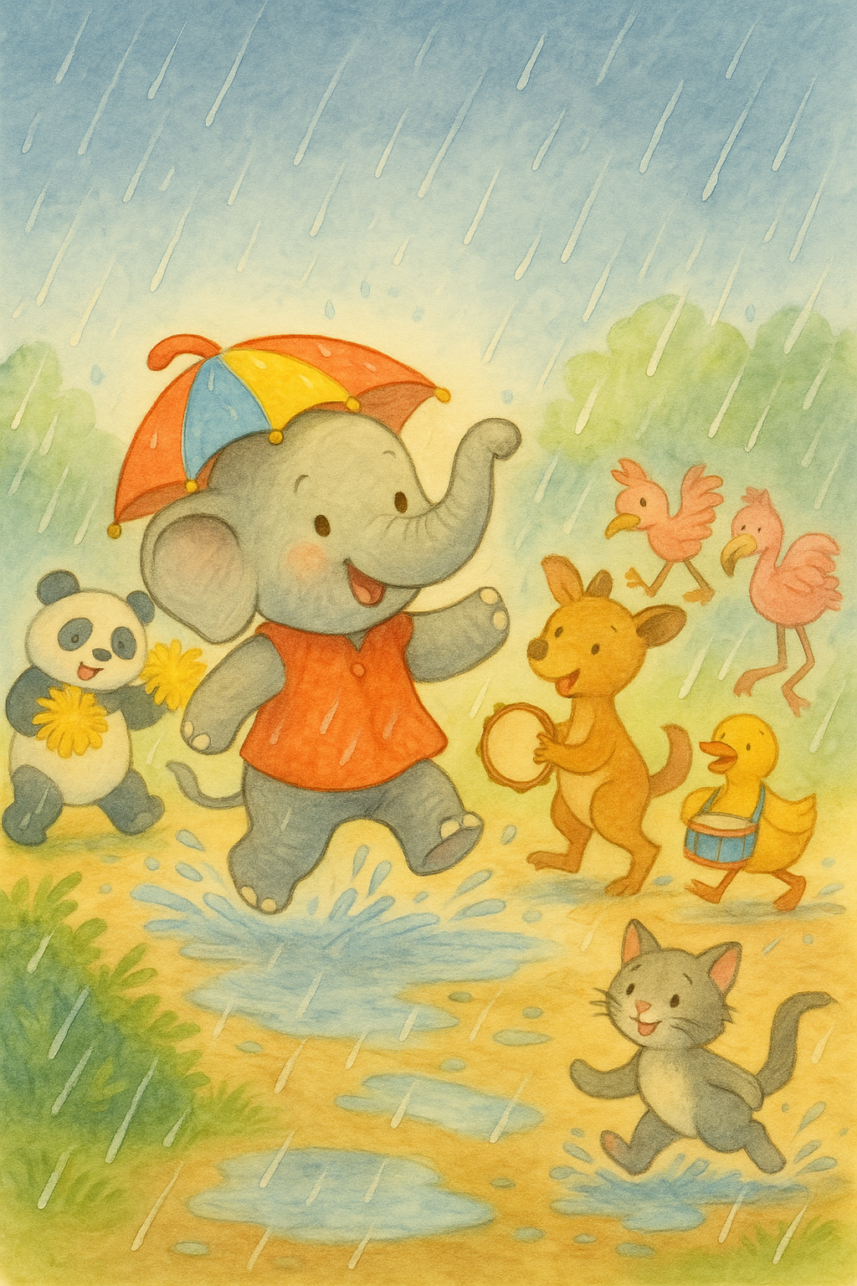

The End

The mayor owl declared,   
“From now on, we shall have two parades every year: one for sunshine, and one for rain!”   
That parade was Ellie’s favorite.

The turtle tap-danced through the splashes. Ducks quacked in rhythm, and even the owl clapped his wings along to the beat. It wasn’t the Sunny Parade. It was something better: a Rainy Day Parade full of giggles and splashes and heart. When it was over,   
everyone was soaked but smiling.